DriveTrust AI
AI-Assisted Two-Wheeler & Four-Wheeler Driving Compliance Platform
Consolidated Project Document — Scope, Architecture, AI Pipeline, Backend & Build Plan
Version 2.0 · Scope Expanded — Two-Wheeler & Four-Wheeler Pilot
Prepared for internal team review

1. Executive Summary
DriveTrust AI is an AI-assisted driving-behaviour detection and reporting platform for two-wheeler and four-wheeler drivers. A driver-facing mobile app captures evidence, an AI pipeline analyses it for road-safety violations, a Supabase-backed service persists results and maintains a per-driver Trust Score, and a React admin dashboard lets an authorised reviewer confirm flags and issue advisory notices.
This document consolidates every decision made to date into one coherent specification: the locked project scope, the system architecture, the full detection list, the AI model pipeline and model-selection reasoning, the database and API design, the phased build plan, and the deployment approach. Earlier drafts of this project described three different framings (a citizen-reporting app, an insurance dashcam product, and a backend proof-of-concept) with contradicting assumptions about vehicle type and camera setup. Section 2 resolves that contradiction and reflects the current, expanded scope: two-wheeler and four-wheeler compliance checks, curated down to what is realistically buildable rather than every capability a full traffic-rule-compliance system could theoretically cover.

2. Locked Project Scope (v1 Pilot)
The pilot targets two-wheeler and four-wheeler drivers, with the front-camera compliance check conditional on vehicle type. This supports both vehicle types with one pipeline architecture rather than picking one — only the front-camera model swaps (helmet vs. seatbelt) based on the declared vehicle type at submission.

2.1 What v1 includes
- Vehicle types: two-wheelers (motorcycles/scooters) and four-wheelers, selected per submission.
- Front camera, self-check (vehicle-type conditional): helmet worn, for two-wheeler riders; seatbelt worn, for four-wheeler drivers — two separate trained models, not merged, so each can be labelled and iterated independently.
- Front camera, both vehicle types: mobile phone usage — free, reuses the existing COCO-pretrained detector's cell-phone class with a proximity heuristic, no new model required.
- Back/road camera: helmet compliance and triple-riding for two-wheelers, vehicle classification (car/bus/truck/motorcycle/bicycle) for general road context, and number plate reading for all vehicle types.
- Capture mode: single clip or short video capture and manual submission — not a continuous always-on recording mode.
- AI output is an advisory flag for human review. It is never an automatic fine — the platform has no legal authority to issue one; only an authorised admin, after review, can confirm a flag and trigger a notice.
- Trust Score is a defined, numeric, insert-only history (see Section 8.3), not an undefined “simulated recommendation.”

2.2 What is explicitly out of scope for v1

Deferred to Phase 2 — feasible, just sequenced later
- Signal violation, wrong-side driving, and tailgating/following-distance detection (Section 4.3).
- Sensor-based self-driving analysis and GPS-based speed compliance — depend on continuous background capture, deferred with it (Section 6).
- Continuous dual-camera dashcam mode with a rolling local buffer and automatic event triggers (Section 6).

Cut from the roadmap for the foreseeable pilot
- Lane detection/departure, road sign recognition, overtaking rules, collision-risk prediction, pedestrian failure-to-yield, parking violations, indicator compliance, and drowsiness detection — assessed as disproportionate effort, not just deferred; reasoning in Section 4.6.

Also out of scope
- Insurance integration (premium/discount calculation) — future work.
- Automated fine issuance, payment collection, or any action with real legal/financial consequence without human confirmation.

3. System Architecture
The platform has four independent layers, each with a single responsibility. This separation lets the AI, backend, and frontend teams work in parallel without blocking one another.
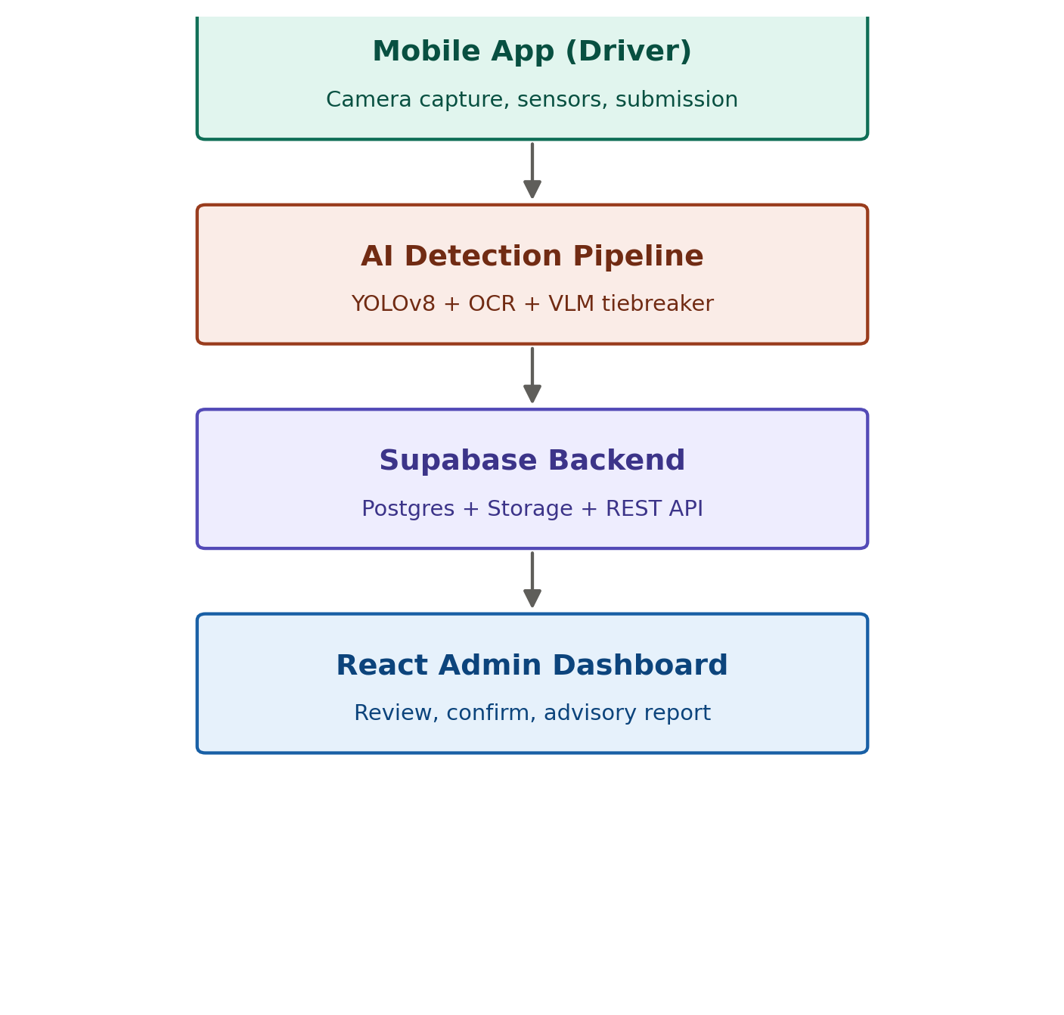
Figure 1 — DriveTrust AI ecosystem overview

3.1 Layer responsibilities
Layer | Responsibility
Mobile app (driver) | Captures evidence (photo/video), collects category input, submits to the backend API.
AI detection pipeline | Runs YOLOv8 detection, plate OCR, rule-based scoring, and a VLM tiebreaker for ambiguous cases.
Supabase backend | Managed Postgres database, private Storage for evidence media, and the data layer behind the REST API.
React admin dashboard | Report queue, evidence review, trust-score history, and the confirm/reject action that produces an advisory notice.

4. Detection List
Curated down to what is realistically buildable with the current pipeline and available datasets, rather than every capability a full traffic-rule-compliance system could theoretically cover. Section 4.6 documents what was deliberately cut, and why.

4.1 Front camera — self-check (vehicle-type conditional)
- Helmet worn / no helmet — two-wheeler riders. Existing trained model.
- Seatbelt worn / not worn — four-wheeler drivers. New model, same build pattern as the helmet model.
- Mobile phone usage — both vehicle types. Free: the existing COCO-pretrained detector already has a cell-phone class; adds a proximity heuristic (phone bounding box near hand/ear), no new training required.

4.2 Road camera — vehicle & identity (near-term)
- Helmet worn / no helmet, for other two-wheeler riders in frame.
- Rider count and triple-riding (3+ riders on one two-wheeler).
- Vehicle classification (car/bus/truck/motorcycle/bicycle) — free, already covered by the COCO-pretrained detector.
- Auto-rickshaw classification — not a COCO class, needs fine-tuning; check for an existing Indian auto-rickshaw dataset before collecting one from scratch.
- Number plate detection and OCR reading (identity match — not itself a violation).
- Persistent vehicle tracking (ByteTrack) — algorithmic, no training required.

4.3 Road camera — traffic rules (Phase 2)
- Signal violation — the existing detector already locates traffic lights as a bounding box (COCO class); the light's colour state is read via a simple crop and brightest-region colour check, not a trained classifier.
- Wrong-side driving — no new model; compares each tracked vehicle's ByteTrack movement vector against a calibrated expected direction for the camera mount.
- Tailgating / unsafe following distance — no new model; uses bounding-box size as a distance proxy and frame-to-frame closing speed from ByteTrack. Depth estimation is a possible later upgrade, not a v1 requirement.

4.4 Sensor-based & GPS (deferred with continuous capture mode)
- Harsh braking, sudden acceleration, sharp cornering — accelerometer/gyroscope thresholds, mobile-side.
- Over-speeding — GPS speed compared against the posted limit via an OpenStreetMap Overpass API lookup; a data-integration task, not a computer-vision task.

4.5 Ambiguous-case resolution
- VLM tiebreaker: reviews the full evidence clip only when the rule engine's confidence lands in the needs_review band. It does not detect new violation types — it confirms or downgrades what the rule engine already flagged as uncertain. Gemini (Flash / Flash-Lite) is the primary choice; NVIDIA Nemotron 3 Nano Omni is a free, video-optimised candidate under evaluation alongside it (Section 5.2).

4.6 Deliberately cut from the roadmap
These appeared in an earlier, broader traffic-rule-compliance roadmap but are assessed as disproportionate effort for the current team and timeline, not simply deferred:
- Lane detection / departure — needs a semantic segmentation model (e.g. a LaneNet-class architecture), fundamentally different from the YOLO-based pipeline, not an incremental addition.
- Road sign recognition — no strong Indian-specific public dataset; would require collecting and labelling one from scratch.
- Overtaking rules, collision-risk prediction, pedestrian failure-to-yield — require multi-frame relative-motion reasoning across several tracked vehicles at once; research-level computer vision, not pilot-level.
- Parking violations — needs static no-parking-zone context with no current data source.
- Indicator compliance — small blinking-object detection with a high false-positive rate relative to the value it adds.
- Drowsiness detection (eye closure, yawning, head nodding) — needs a face-mesh pipeline, a different architecture from the current detection stack.

5. AI Model Ingestion Pipeline
What happens to one submitted clip, in order, from upload to a final report:
- Frame extraction — sample the incoming video at a fixed interval.
- YOLO detection — person/motorcycle/vehicle-class, helmet, seatbelt, plate, and traffic-light-location models run on every sampled frame; front-camera self-check reuses the helmet or seatbelt model depending on declared vehicle type.
- Vehicle tracking — ByteTrack assigns a persistent ID across frames so the same vehicle is not counted twice within a clip.
- Rule engine — produces a per-frame verdict: rider count, helmet association, triple-riding flag.
- OCR — the plate detection crop is passed to EasyOCR and validated against the Indian plate format.
- Verification / aggregation — per-frame verdicts are combined into one clip-level severity score and a status tier: auto_flagged, needs_review, or insufficient_evidence.
- VLM tiebreaker — fires only when status = needs_review; the whole clip is sent to Gemini for a final call.
- Report generation — final JSON report, evidence frames, and a trust_score_delta are written and passed to the backend.
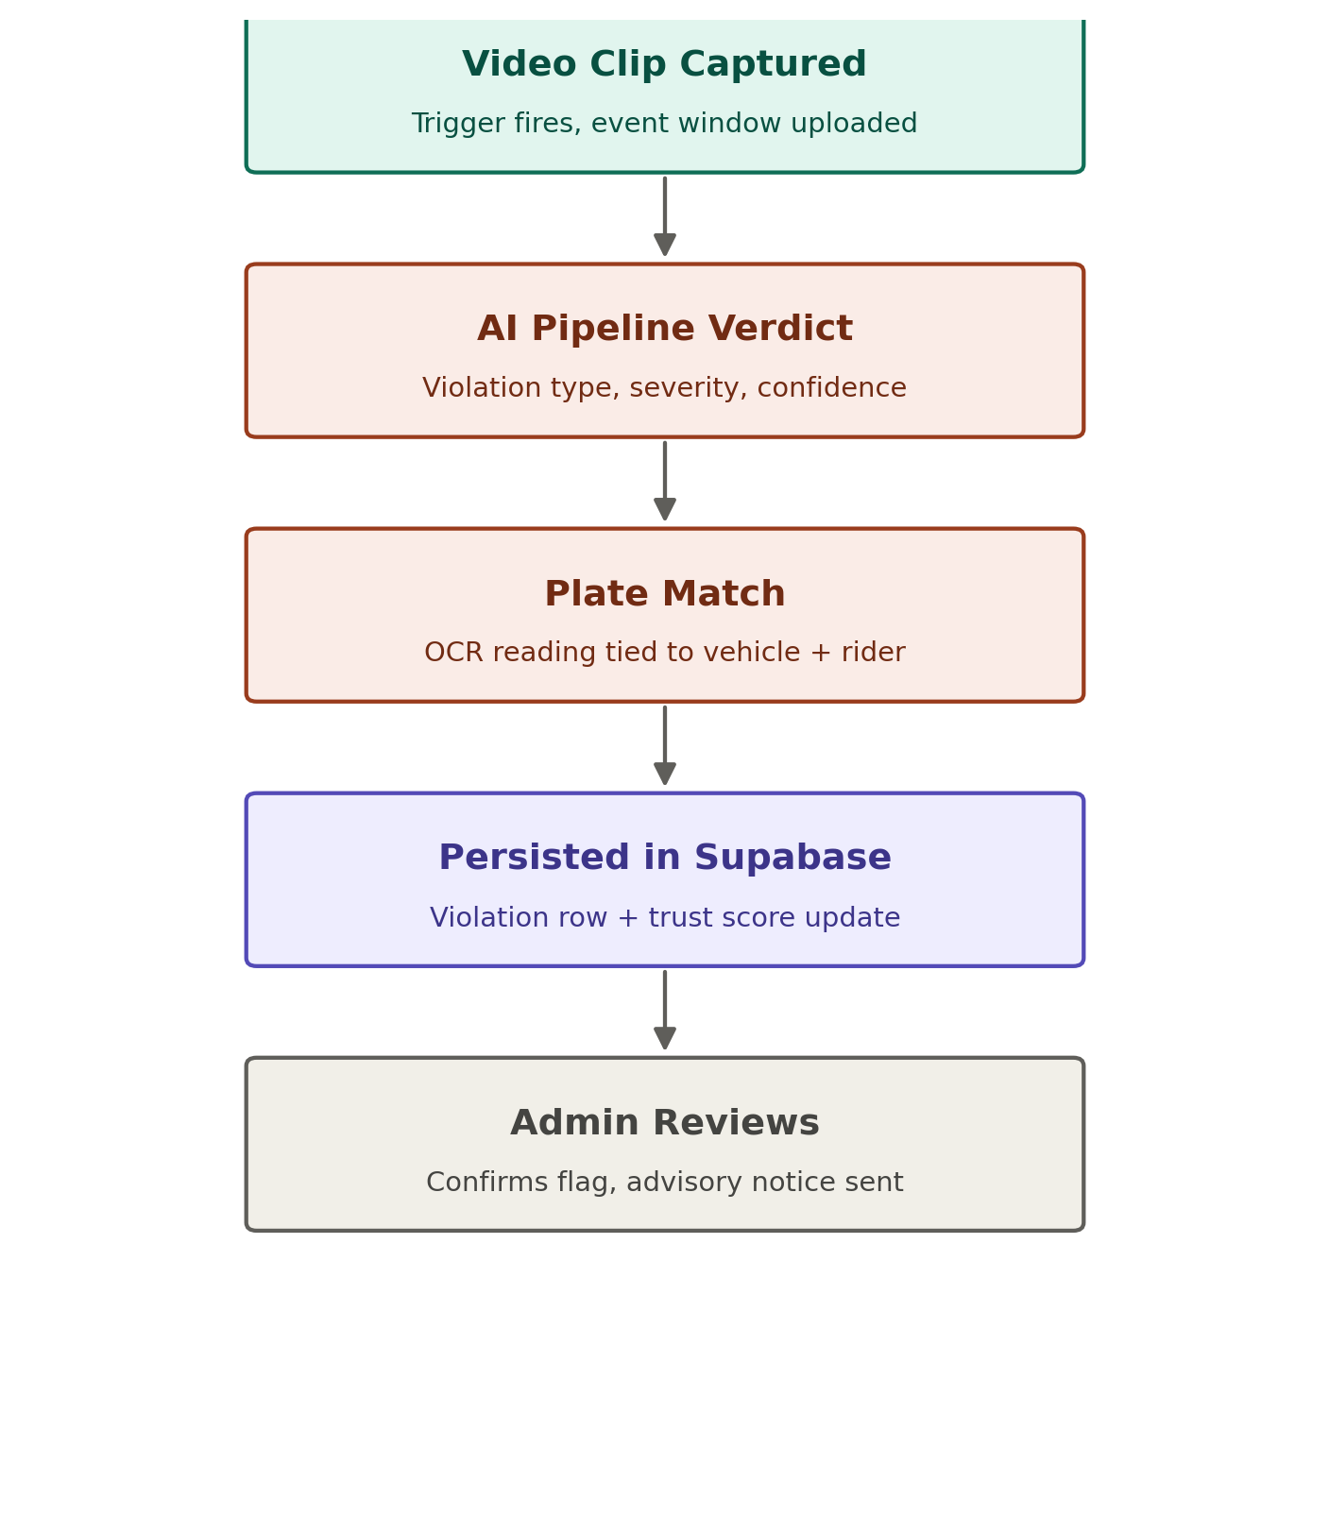
Figure 2 — Detection-to-advisory flow for a single event

5.1 Current build status
Detection | Model | Dataset | Status
Person, motorcycle, vehicle class | yolov8n.pt (COCO pretrained) | None needed | Done
Helmet / no-helmet (road + self) | helmet_model.pt | Roboflow helmet dataset | Trained
Mobile phone usage | yolov8n.pt (COCO pretrained) + heuristic | None needed | Done
Traffic light location | yolov8n.pt (COCO pretrained) + colour heuristic | None needed | Done (Phase 2 use)
License plate | ampr.pt | External (already trained) | Trained
Seatbelt / no-seatbelt (4-wheeler) | New model, same pattern as helmet_model.pt | New dataset — not yet collected | Not started
Auto-rickshaw classification | Fine-tuned YOLOv8n | Check Roboflow before collecting new data | Not started
Vehicle tracking | ByteTrack (algorithmic) | None needed | Not integrated
Ambiguous-case tiebreak | Gemini VLM (API); Nemotron 3 Nano Omni (API, under evaluation) | N/A — API-based | Not integrated

5.2 VLM / reasoning model selection
Several models were evaluated for the ambiguous-case tiebreaker role beyond the originally planned Gemini API:
Model | Modality | Verdict
Gemini (Flash / Flash-Lite) | Native video input | Primary choice — proven, cheap, already integrated into the plan.
NVIDIA Nemotron 3 Nano Omni | Native video, image, audio, text | Free via NVIDIA's hosted API; a video-optimised architecture (Efficient Video Sampling) purpose-built for exactly this kind of clip-review task. Worth a side-by-side evaluation against Gemini before adopting.
NVIDIA Nemotron-3-Nano-30B-A3B (FP8) | Text only | Rejected — cannot process video or images at all; wrong modality for this role.
NVIDIA Alpamayo 2 Super | Multi-camera video + ego-motion history | Rejected — built for autonomous-vehicle trajectory planning (the ego vehicle's own driving decisions), not third-party violation detection. 34B parameters, needs multi-GPU (70GB+ VRAM) hardware disproportionate to this pilot.
Kimi K3 | Native video, image, text | Rejected — technically capable, but a 2.8T-parameter frontier flagship priced for long-horizon agentic coding, roughly 25x the per-token cost of Gemini Flash-Lite. Disproportionate for a bounded confirm/reject judgment.
Local hardware (RTX 3060, 6GB VRAM) is sufficient for YOLOv8n/s fine-tuning and inference across all detection models above. None of the VLM options are self-hosted — all run via a hosted API, so VRAM is not a constraint for the tiebreaker role.

5.3 AI engineering workflow
Build order for the AI pipeline work specifically, independent of backend/frontend progress:
- Environment setup — Python venv, dependencies, GPU verification.
- Baseline validation — confirm the existing pipeline still runs end-to-end before changing anything.
- Vehicle tracking — integrate ByteTrack; no new data required.
- Front-camera self-check validation — test the helmet/seatbelt models against front-facing footage specifically; domain shift from road-facing training data is a real risk, not assumed away.
- VLM tiebreaker integration — wire the chosen model(s) into the needs_review branch.
- Evaluation on a labelled test set — precision/recall, used to tune severity thresholds against real numbers.
- Output contract — finalise the JSON fields the backend consumes.
- Tests, docs, and commit hygiene.

6. Future Capture Mode: Continuous Dashcam (Reference Only)
Deferred per Section 2.2, but specified here so the storage and bandwidth design is not lost. If/when the platform moves to a continuous phone-as-dashcam mode with a rolling local buffer:
Stream | Resolution | Bitrate | 30s size
Back camera (road) | 1080p H.264 | ~6 Mbps | ~22.5 MB
Front camera (driver) | 720p H.264 @15fps | ~1.5 Mbps | ~5.6 MB
Combined (rolling buffer) | — | — | ~28 MB / 30s
The rolling buffer overwrites itself continuously and never leaves the device. Only a flagged event window (5–10 minutes, both cameras) is compressed (H.265, reduced bitrate) and uploaded — approximately 65–75 MB for a 5-minute clip and 130–150 MB for a 10-minute clip, versus ~560 MB uncompressed.

7. Technology Stack
Layer | Technology | Notes
Mobile app | Android (Flutter or native) | Camera capture, submission flow, category selection.
AI pipeline | Python, YOLOv8 (Ultralytics), OpenCV, EasyOCR, ByteTrack | Existing RakshaRide codebase, extended.
VLM tiebreaker | Gemini API (primary); NVIDIA Nemotron 3 Nano Omni (free, under evaluation) | Ambiguous-case review only; both API-based, no local GPU needed.
Backend API | FastAPI (Python) | Sits between clients and Supabase; holds the service-role key.
Database & storage | Supabase (PostgreSQL + Storage) | Managed Postgres, private bucket for evidence media.
Admin dashboard | React | Report queue, review, trust-score history, dashboard stats.
Local training hardware | RTX 3060 6GB laptop (140W TGP) | Sufficient for YOLOv8n/s fine-tuning and inference testing.

8. Backend: Database and API Design

8.1 Core tables (Supabase / PostgreSQL)
Table | Purpose
users | Application users.
drivers | Driver/rider information.
vehicles | Vehicle details, keyed by number plate — the field the AI pipeline's OCR output matches against.
reports | Submitted evidence reports; created first with status pending.
violations | AI-detected violations linked to a report; ai_response stored as JSONB.
trust_score_history | Insert-only log of every score change — never an UPDATE. Current score = latest row.
notifications | Advisory notices sent to drivers after admin confirmation.
audit_log | Report creation, violation generation, score updates, and admin actions.

8.2 REST API endpoints
Method | Endpoint | Purpose
POST | /reports | Create a new driving report.
GET | /reports/{id} | Retrieve report details.
POST | /violations | Store AI-generated violations.
GET | /drivers/{id} | Retrieve driver information.
GET | /drivers/{id}/trust-score | Retrieve the current trust score (latest history row).
GET | /dashboard/stats | Retrieve aggregated dashboard statistics.

8.3 Trust Score model
Every score change is a new row in trust_score_history (driver_id, delta, new_score, timestamp, reason) rather than an overwrite of a single value. Reference starting formula, to be tuned against the validation set in Section 12:
- −15 points for each confirmed no-helmet violation.
- −25 points for each confirmed triple-riding violation.
- +2 points per consecutive clean-report day, with a decay-back-up mechanic capped at the starting score.
Access pattern: FastAPI holds the Supabase service-role key and is the only component with direct database access. Both the mobile app and the admin dashboard talk to FastAPI, never to Supabase directly — this keeps Auth/RLS additions (Section 11) from requiring any client-side rework later.

9. End-to-End Flow: One Report, Start to Finish
- Driver captures evidence in the mobile app and submits it.
- FastAPI creates a reports row (status: pending) and hands the clip to the AI pipeline.
- The AI pipeline (Section 5) returns a verdict: violation type, severity, confidence, and a plate reading.
- The plate reading matches an existing vehicles row, or creates one.
- FastAPI writes a violations row and a trust_score_history row, and updates the report status.
- An audit_log entry is recorded for each of the above writes.
- The React admin dashboard displays the report in the review queue.
- An admin reviews the evidence and either confirms (triggers a notifications row / advisory) or rejects the flag (logged with a reason).

10. Phased Build Plan
Requested build order: admin and mobile app first, then backend, then AI model — made workable by freezing the API contract (Phase 1) before any screen is built, so mobile and admin can be developed against a fixed mock and swapped to the real backend later without rework.
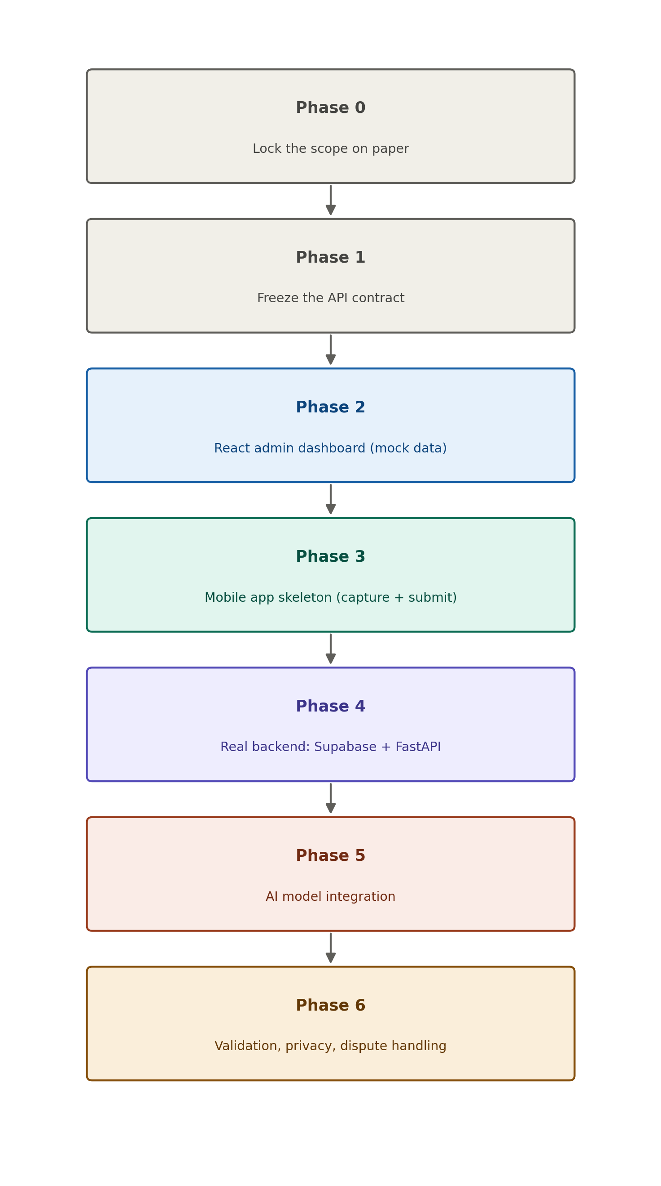
Figure 3 — Seven-phase build order
Phase | Deliverable | Closes which gap
0 — Lock scope | Written scope doc: vehicle type, camera roles, trust-score formula, explicit non-goals. | Identity contradiction; undefined fine authority; undefined trust score.
1 — Freeze contract | Fixed JSON report/violation shape and endpoint list. | Lets mobile/admin build in parallel without later rework.
2 — Admin dashboard | React app against mock data: queue, review, trust-score history, stats. | Can start immediately, independent of backend/AI progress.
3 — Mobile app skeleton | Capture, vehicle-type + category selection, submission — against the mock contract. | Avoids over-scoping into full dashcam mode too early.
4 — Real backend | 8-table Supabase schema + FastAPI endpoints; mobile/admin swapped from mock to real. | Backend and database requirement.
5 — AI model integration | RakshaRide pipeline wired behind POST /violations; ByteTrack, seatbelt/phone/vehicle-class detection, and VLM tiebreaker added. | Connects the already-built detection code to the live system, extended to the current two-wheeler + four-wheeler scope.
6 — Validation & privacy | Labeled test set with precision/recall; consent notice; retention policy; dispute path. | No ground-truth validation; no privacy/legal treatment; no appeal path.

10.1 Repository structure
The AI pipeline is developed on a dedicated branch containing only the detection-pipeline codebase, isolated from the mobile app, admin dashboard, and backend code on the main branch. This lets AI work and backend/frontend work proceed independently and merge via pull request once each side is ready, without either blocking the other.

11. Post-Pilot Roadmap

11.1 Phase 2 — near-term, buildable
- Signal violation, wrong-side driving, and tailgating/following-distance detection (Section 4.3).
- Sensor-based self-driving analysis (harsh braking, cornering) and GPS-based speed compliance.
- Continuous dual-camera dashcam mode with rolling local buffer and event-triggered upload (Section 6).

11.2 Phase 3 — revisit only if team or resources grow
- Drowsiness detection, lane detection/departure, road sign recognition, collision-risk prediction, parking violations, overtaking rules, and indicator compliance (Section 4.6).
- Insurance integration: premium/discount recommendation engine.
- Google/Apple/Microsoft OAuth login and Row Level Security via Supabase Auth.
- Realtime dashboard updates, Edge Functions for notifications, pg_cron for evidence archiving.

12. Validation, Privacy, and Dispute Handling

12.1 Validation
Build a small labeled test set of known-violation and known-clean clips before trusting the severity formula. Report precision and recall against it; tune the formula and trust-score weights against real numbers instead of untested assumptions.

12.2 Privacy
- Consent notice in the mobile app before capture begins.
- Retention policy: delete raw evidence clips after a fixed window (e.g. 30 days) unless the report is confirmed and under active review.
- Evidence media stored in a private Storage bucket; only the object URL is written to Postgres, never public by default.

12.3 Dispute handling
A driver flagged in error needs a path to contest it. Minimum viable version for v1: the admin who reviews a report can revert a confirmed flag, with a required logged reason in audit_log — this is a process gap in the original plan, not an afterthought.

13. Deployment Plan
Proposed approach for a pilot-scale deployment, consistent with the technology stack already chosen. This is a plan, to be executed in Phase 4 onward — not yet implemented.
Component | Deployment approach
Supabase (DB + Storage) | Managed Supabase project (free tier for pilot); upgrade to a paid tier only if storage/traffic limits are hit during real testing.
FastAPI backend | Container deployed to a low-cost host (e.g. Render, Railway, or Fly.io free/starter tier) connected to Supabase via the service-role key stored as an environment secret.
React admin dashboard | Static build deployed to Vercel or Netlify, pointed at the FastAPI backend URL.
Mobile app | Distributed as a direct APK or via Google Play internal testing track during the pilot, before any public release.
AI pipeline | Runs as part of the FastAPI service (or a separate worker process) on the same host; VLM calls go out to the Gemini API, no local GPU required in production.
Secrets management | API keys and the Supabase service-role key kept as host-level environment variables, never committed to the repository or shipped to any client.
This keeps pilot infrastructure cost close to zero, relying on free/low-cost tiers for local GPU-adjacent needs and short-term cloud bursts rather than always-on hosting.

14. Disclaimer
This document describes a pilot proof-of-concept. All AI-generated outputs are advisory recommendations for human review and do not constitute an enforcement decision, a legal fine, or a final determination of any violation. Any deployment beyond an internal pilot requires a review of applicable data-protection and traffic-enforcement law before proceeding.

End of document.

